**CSCI 490 Research Query Results (2014 – 2015)**

# Note: Total Enrollment overshoots the ethnicity/gender totals by 64,252 students

SELECT SUM(total_enrollment) FROM all_school_info;

* Total: 510,127 enrolled students reported

################################# Ethnicity ####################################

**What is the overall distribution of ethnicities in Los Angeles County schools?**

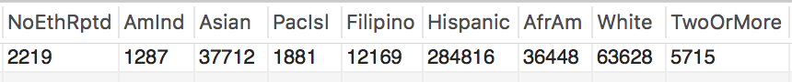

SELECT

SUM(NoEthRptd) AS NoEthRptd,

SUM(AmInd) AS AmInd,

SUM(Asian) AS Asian,

SUM(PacIsl) AS PacIsl,

SUM(Filipino) AS Filipino,

SUM(Hispanic) AS Hispanic,

SUM(AfrAm) AS AfrAm,

SUM(White) AS White,

SUM(TwoOrMore) AS TwoOrMore

FROM all_school_info;

* Total: 445,875 students with reported ethnicities



#TODO: find a percentage function to avoid hardcoding

SELECT

SUM(NoEthRptd)/4458.75 AS NoEthRptd,

SUM(AmInd)/4458.75 AS AmInd,

SUM(Asian)/4458.75 AS Asian,

SUM(PacIsl)/4458.75 AS PacIsl,

SUM(Filipino)/4458.75 AS Filipino,

SUM(Hispanic)/4458.75 AS Hispanic,

SUM(AfrAm)/4458.75 AS AfrAm,

SUM(White)/4458.75 AS White,

SUM(TwoOrMore)/4458.75 AS TwoOrMore

FROM all_school_info;

**What is the ethnicity distribution at every income tier in Los Angeles County?**

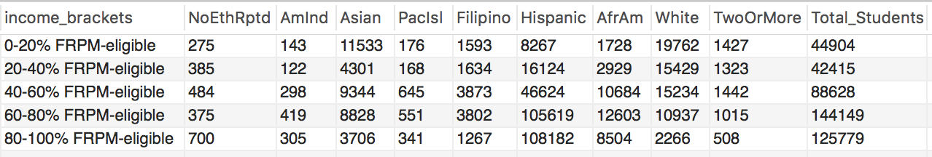

|  |  |  |
| --- | --- | --- |
|  | **0 – 20% FRPM-eligible** | **80 – 100% FRPM-eligible** |
| **Asian** | **25.7%** | **2.9%** |
| **Hispanic** | **18.4%** | **86.0%** |
| **African American** | **3.8%** | **6.8%** |
| **White** | **44.0%** | **1.8%** |

#Raw

SELECT

CASE

WHEN FRPM_eligible_percent > 0.8 THEN '80-100% FRPM-eligible'

WHEN FRPM_eligible_percent BETWEEN 0.6 AND 0.8 THEN '60-80% FRPM-eligible'

WHEN FRPM_eligible_percent BETWEEN 0.4 AND 0.6 THEN '40-60% FRPM-eligible'

WHEN FRPM_eligible_percent BETWEEN 0.2 AND 0.4 THEN '20-40% FRPM-eligible'

ELSE '0-20% FRPM-eligible'

END AS 'income_brackets',

SUM(NoEthRptd) AS NoEthRptd,

SUM(AmInd) AS AmInd,

SUM(Asian) AS Asian,

SUM(PacIsl) AS PacIsl,

SUM(Filipino) AS Filipino,

SUM(Hispanic) AS Hispanic,

SUM(AfrAm) AS AfrAm,

SUM(White) AS White,

SUM(TwoOrMore) AS TwoOrMore,

SUM(NoEthRptd)+SUM(AmInd)+SUM(Asian)+SUM(PacIsl)+SUM(Filipino)

+SUM(Hispanic)+SUM(AfrAm)+SUM(White)+SUM(TwoOrMore) AS Total_Students

FROM all_school_info

GROUP BY income_brackets;

#TODO: Percentage

# What is the ethnicity distribution at every income tier for schools that offer CS?

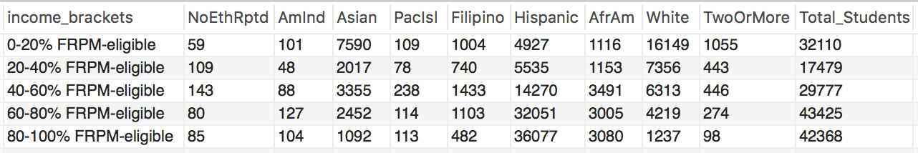

|  |  |  |
| --- | --- | --- |
|  | **0 – 20% FRPM-eligible** | **80 – 100% FRPM-eligible** |
| **Asian** | **23.6%** | **2.6%** |
| **Hispanic** | **15.3%** | **85.2%** |
| **African American** | **3.5%** | **7.3%** |
| **White** | **50.3%** | **2.9%** |

* No significant changes except for that White students make up 6.3% more of the “high-income” bracket in CS schools. Hispanics make up 3.1% less, Asians 2.1% less.

#Raw

SELECT

CASE

WHEN FRPM_eligible_percent > 0.8 THEN '80-100% FRPM-eligible'

WHEN FRPM_eligible_percent BETWEEN 0.6 AND 0.8 THEN '60-80% FRPM-eligible'

WHEN FRPM_eligible_percent BETWEEN 0.4 AND 0.6 THEN '40-60% FRPM-eligible'

WHEN FRPM_eligible_percent BETWEEN 0.2 AND 0.4 THEN '20-40% FRPM-eligible'

ELSE '0-20% FRPM-eligible'

END AS 'income_brackets',

SUM(NoEthRptd) AS NoEthRptd,

SUM(AmInd) AS AmInd,

SUM(Asian) AS Asian,

SUM(PacIsl) AS PacIsl,

SUM(Filipino) AS Filipino,

SUM(Hispanic) AS Hispanic,

SUM(AfrAm) AS AfrAm,

SUM(White) AS White,

SUM(TwoOrMore) AS TwoOrMore,

SUM(NoEthRptd)+SUM(AmInd)+SUM(Asian)+SUM(PacIsl)+SUM(Filipino)

+SUM(Hispanic)+SUM(AfrAm)+SUM(White)+SUM(TwoOrMore) AS Total_Students

FROM all_school_info

WHERE school_id IN (SELECT school_id FROM updated_cs_enrollments)

GROUP BY income_brackets;

#TODO: Percentage

**What is the distribution of ethnicities among schools that offer Computer Science (CS)?**



#Raw

SELECT

SUM(NoEthRptd) AS NoEthRptd,

SUM(AmInd) AS AmInd,

SUM(Asian) AS Asian,

SUM(PacIsl) AS PacIsl,

SUM(Filipino) AS Filipino,

SUM(Hispanic) AS Hispanic,

SUM(AfrAm) AS AfrAm,

SUM(White) AS White,

SUM(TwoOrMore) AS TwoOrMore

FROM all_school_info

WHERE school_id IN (SELECT school_id FROM updated_cs_enrollments);

* Total: 165,159 students with reported ethnicities in schools that offer CS



* Schools that offer CS have 7.1% more White students and 7.7% fewer Hispanic students. Also 1.5% fewer Asian students and 1% fewer African American students.

#Percentage

#TODO: find a percentage function to avoid hardcoding

SELECT

SUM(NoEthRptd)/1651.59 AS NoEthRptd,

SUM(AmInd)/1651.59 AS AmInd,

SUM(Asian)/1651.59 AS Asian,

SUM(PacIsl)/1651.59 AS PacIsl,

SUM(Filipino)/1651.59 AS Filipino,

SUM(Hispanic)/1651.59 AS Hispanic,

SUM(AfrAm)/1651.59 AS AfrAm,

SUM(White)/1651.59 AS White,

SUM(TwoOrMore)/1651.59 AS TwoOrMore

FROM all_school_info

WHERE school_id IN (SELECT school_id FROM updated_cs_enrollments);

################################# Income #################################

**What is the overall distribution of income in Los Angeles County schools?**

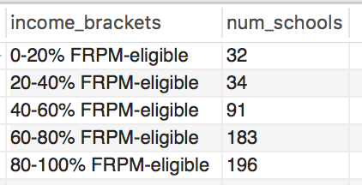

* GRAPH: 2-bar: with CS/without

#Raw

SELECT

CASE

WHEN FRPM_eligible_percent > 0.8 THEN '80-100% FRPM-eligible'

WHEN FRPM_eligible_percent BETWEEN 0.6 AND 0.8 THEN '60-80% FRPM-eligible'

WHEN FRPM_eligible_percent BETWEEN 0.4 AND 0.6 THEN '40-60% FRPM-eligible'

WHEN FRPM_eligible_percent BETWEEN 0.2 AND 0.4 THEN '20-40% FRPM-eligible'

ELSE '0-20% FRPM-eligible'

END AS 'income_brackets',

COUNT(*) AS num_schools

FROM all_school_info

GROUP BY income_brackets;

#0-20: 32 schools

#20-40: 34 schools

#40-60: 91 schools

#60-80: 183 schools

#80-100: 196 schools

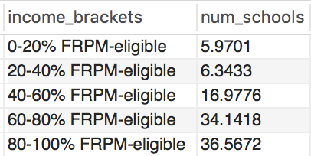

#Percentage

SELECT

CASE

WHEN FRPM_eligible_percent > 0.8 THEN '80-100% FRPM-eligible'

WHEN FRPM_eligible_percent BETWEEN 0.6 AND 0.8 THEN '60-80% FRPM-eligible'

WHEN FRPM_eligible_percent BETWEEN 0.4 AND 0.6 THEN '40-60% FRPM-eligible'

WHEN FRPM_eligible_percent BETWEEN 0.2 AND 0.4 THEN '20-40% FRPM-eligible'

ELSE '0-20% FRPM-eligible'

END AS 'income_brackets',

COUNT(*)/5.36 AS num_schools

FROM all_school_info

GROUP BY income_brackets;

**How many schools are there where most of their students are FRPM-eligible?**

SELECT COUNT(*) FROM all_school_info WHERE FRPM_eligible_percent > 0.5;

* 437 schools
* 81.5% of schools

**What is the distribution of income among schools that offer Computer Science?**

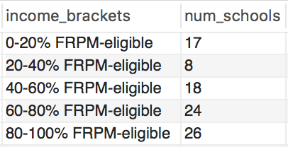

#Raw

SELECT

CASE

WHEN FRPM_eligible_percent > 0.8 THEN '80-100% FRPM-eligible'

WHEN FRPM_eligible_percent BETWEEN 0.6 AND 0.8 THEN '60-80% FRPM-eligible'

WHEN FRPM_eligible_percent BETWEEN 0.4 AND 0.6 THEN '40-60% FRPM-eligible'

WHEN FRPM_eligible_percent BETWEEN 0.2 AND 0.4 THEN '20-40% FRPM-eligible'

ELSE '0-20% FRPM-eligible'

END AS 'income_brackets',

COUNT(*) AS num_schools

FROM all_school_info

WHERE school_id IN (SELECT school_id FROM updated_cs_enrollments)

GROUP BY income_brackets;

* 93 LA schools that offer CS

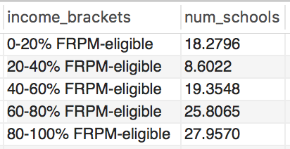

#Percentage

SELECT

CASE

WHEN FRPM_eligible_percent > 0.8 THEN '80-100% FRPM-eligible'

WHEN FRPM_eligible_percent BETWEEN 0.6 AND 0.8 THEN '60-80% FRPM-eligible'

WHEN FRPM_eligible_percent BETWEEN 0.4 AND 0.6 THEN '40-60% FRPM-eligible'

WHEN FRPM_eligible_percent BETWEEN 0.2 AND 0.4 THEN '20-40% FRPM-eligible'

ELSE '0-20% FRPM-eligible'

END AS 'income_brackets',

COUNT(*)/.93 AS num_schools

FROM all_school_info

WHERE school_id IN (SELECT school_id FROM updated_cs_enrollments)

GROUP BY income_brackets;

################################# Gender #################################

**What is the gender distribution of Los Angeles County?**

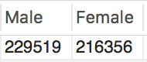

#Raw

SELECT

SUM(M) AS Male,

SUM(F) AS Female

FROM all_school_info;

* Total: 445875 students with reported genders

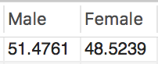

#Percentage

SELECT

SUM(M)/4458.75 AS Male,

SUM(F)/4458.75 AS Female

FROM all_school_info;

**What is the gender distribution at every income tier in Los Angeles County?**

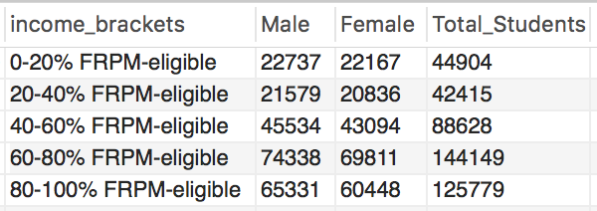

#Raw

SELECT

CASE

WHEN FRPM_eligible_percent > 0.8 THEN '80-100% FRPM-eligible'

WHEN FRPM_eligible_percent BETWEEN 0.6 AND 0.8 THEN '60-80% FRPM-eligible'

WHEN FRPM_eligible_percent BETWEEN 0.4 AND 0.6 THEN '40-60% FRPM-eligible'

WHEN FRPM_eligible_percent BETWEEN 0.2 AND 0.4 THEN '20-40% FRPM-eligible'

ELSE '0-20% FRPM-eligible'

END AS 'income_brackets',

SUM(M) AS Male,

SUM(F) AS Female,

SUM(M)+SUM(F) AS Total_Students

FROM all_school_info

GROUP BY income_brackets;

#TODO: Percentage

**What is the gender distribution among schools that offer Computer Science (CS)?**

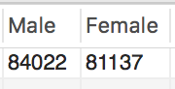

#Raw

SELECT

SUM(M) AS Male,

SUM(F) AS Female

FROM all_school_info

WHERE school_id IN (SELECT school_id FROM updated_cs_enrollments);

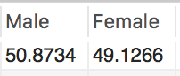

#Percentage

SELECT

SUM(M)/1651.59 AS Male,

SUM(F)/1651.59 AS Female

FROM all_school_info

WHERE school_id IN (SELECT school_id FROM updated_cs_enrollments);

**What is the gender distribution by ethnicity in Los Angeles County?**

#TODO: Have to make a new table with a different structure for this

#############################################################################

########################### CS-Offering Schools #################################

#############################################################################

SELECT COUNT( DISTINCT(school_id) ) FROM updated_cs_enrollments;

* 93 public high schools offer CS in Los Angeles County

SELECT SUM(cs_enrollment) FROM updated_cs_enrollments;

* 8,549 students enrolled in CS in Los Angeles County from 2014 - 2015

################################# Ethnicity #################################

**What is the distribution of ethnicities enrolled in CS?**

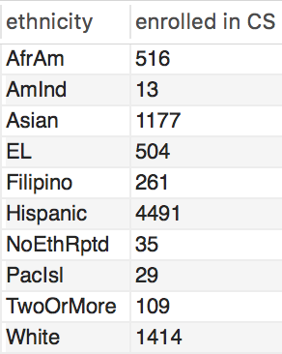

#Raw

SELECT ethnicities.ethnicity, SUM(updated_cs_enrollments.cs_enrollment) AS `enrolled in CS`

FROM ethnicities

INNER JOIN updated_cs_enrollments ON ethnicities.ethnicity_id = updated_cs_enrollments.ethnicity_id

GROUP BY ethnicities.ethnicity;

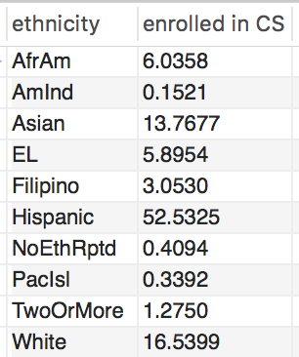

#Percentage

SELECT ethnicities.ethnicity, SUM(updated_cs_enrollments.cs_enrollment)/85.49 AS `enrolled in CS`

FROM ethnicities

INNER JOIN updated_cs_enrollments ON ethnicities.ethnicity_id = updated_cs_enrollments.ethnicity_id

GROUP BY ethnicities.ethnicity;

################################# Income ######################################

**What percentage of the students taking CS attend a low-income school? "High-income" school?**

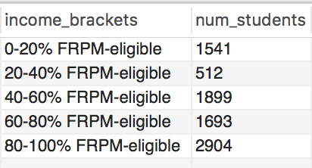

#Raw

SELECT

CASE

WHEN FRPM_eligible_percent > 0.8 THEN '80-100% FRPM-eligible'

WHEN FRPM_eligible_percent BETWEEN 0.6 AND 0.8 THEN '60-80% FRPM-eligible'

WHEN FRPM_eligible_percent BETWEEN 0.4 AND 0.6 THEN '40-60% FRPM-eligible'

WHEN FRPM_eligible_percent BETWEEN 0.2 AND 0.4 THEN '20-40% FRPM-eligible'

ELSE '0-20% FRPM-eligible'

END AS 'income_brackets',

SUM(updated_cs_enrollments.cs_enrollment) AS num_students

FROM all_school_info

INNER JOIN updated_cs_enrollments ON all_school_info.school_id = updated_cs_enrollments.school_id

GROUP BY income_brackets;

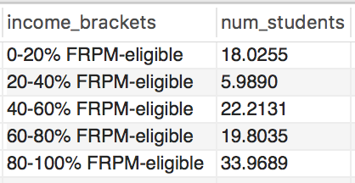

#Percentage

SELECT

CASE

WHEN FRPM_eligible_percent > 0.8 THEN '80-100% FRPM-eligible'

WHEN FRPM_eligible_percent BETWEEN 0.6 AND 0.8 THEN '60-80% FRPM-eligible'

WHEN FRPM_eligible_percent BETWEEN 0.4 AND 0.6 THEN '40-60% FRPM-eligible'

WHEN FRPM_eligible_percent BETWEEN 0.2 AND 0.4 THEN '20-40% FRPM-eligible'

ELSE '0-20% FRPM-eligible'

END AS 'income_brackets',

SUM(updated_cs_enrollments.cs_enrollment)/85.49 AS num_students

FROM all_school_info

INNER JOIN updated_cs_enrollments ON all_school_info.school_id = updated_cs_enrollments.school_id

GROUP BY income_brackets;

################################# Gender ######################################

**What is the gender distribution of students enrolled in CS?**

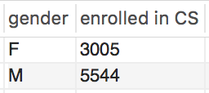

#Raw

SELECT genders.gender, SUM(updated_cs_enrollments.cs_enrollment) AS `enrolled in CS`

FROM genders

INNER JOIN updated_cs_enrollments ON genders.gender_id = updated_cs_enrollments.gender_id

GROUP BY genders.gender;

#Male: 5544

#Female: 3005

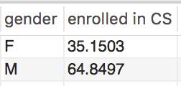

#Percentage

SELECT genders.gender, SUM(updated_cs_enrollments.cs_enrollment)/85.49 AS `enrolled in CS`

FROM genders

INNER JOIN updated_cs_enrollments ON genders.gender_id = updated_cs_enrollments.gender_id

GROUP BY genders.gender;

**What is the gender distribution of the ethnicities enrolled in CS?**

#TODO: put into one table, resort by ID (not alphabetically)

#Raw

#Male

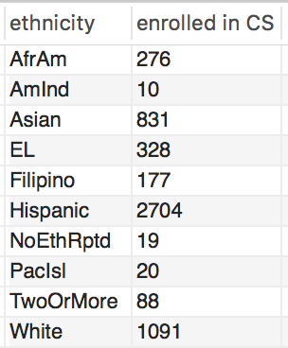

SELECT ethnicities.ethnicity, SUM(updated_cs_enrollments.cs_enrollment) AS `enrolled in CS`

FROM ethnicities

INNER JOIN updated_cs_enrollments ON ethnicities.ethnicity_id = updated_cs_enrollments.ethnicity_id

WHERE gender_id = 1

GROUP BY ethnicities.ethnicity;

#Female

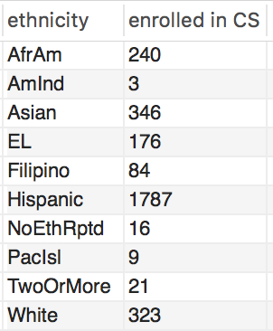

SELECT ethnicities.ethnicity, SUM(updated_cs_enrollments.cs_enrollment) AS `enrolled in CS`

FROM ethnicities

INNER JOIN updated_cs_enrollments ON ethnicities.ethnicity_id = updated_cs_enrollments.ethnicity_id

WHERE gender_id = 2

GROUP BY ethnicities.ethnicity;

#Percentage

#Male

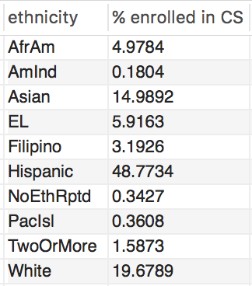

SELECT ethnicities.ethnicity, SUM(updated_cs_enrollments.cs_enrollment)/55.44 AS `% enrolled in CS`

FROM ethnicities

INNER JOIN updated_cs_enrollments ON ethnicities.ethnicity_id = updated_cs_enrollments.ethnicity_id

WHERE gender_id = 1

GROUP BY ethnicities.ethnicity;

#Female

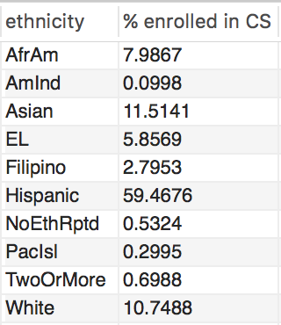

SELECT ethnicities.ethnicity, SUM(updated_cs_enrollments.cs_enrollment)/30.05 AS `% enrolled in CS`

FROM ethnicities

INNER JOIN updated_cs_enrollments ON ethnicities.ethnicity_id = updated_cs_enrollments.ethnicity_id

WHERE gender_id = 2

GROUP BY ethnicities.ethnicity;

#Percentage of the Ethnicities that are Female

|  |  |  |
| --- | --- | --- |
| Ethnicity | Total CS Students | % of CS students that are female |
| African American | 516 | **46.51%** |
| Hispanic | 4491 | **39.79%** |
| Asian | 1177 | **29.40%** |
| White | 1414 | **22.84%** |
| No Eth. Reported | 35 | 45.71% |
| English Learners | 504 | 34.92% |
| Filipino | 261 | 32.18% |
| Pacific Islander | 38 | 23.68% |
| American Indian | 13 | 23.08% |
| Two Or More Eth. | 109 | 19.27% |

* GRAPH

**Results/Conclusions**

Gender

35.2% of the CS students were female – more than double the national percentage of CS graduates that are female (17.9%[1]).

* Unless this trend is very recent, the CS course could either do a better job motivating a career in CS or the colleges could do a better job retaining would-be female CS graduates. Career outlook during college could also be a factor.
* 3-bar: overall gender, CS high school, CS college

A very identifiable pattern was that females belonging to a minority ethnicity were enrolled in CS at much higher proportions than their majority counterparts. Hispanic females made up a 74.2% greater percentage of total CS enrollment than White females, and 35.3% greater percentage than Asian females. More noteworthy, African American females made up 103.6% greater percentage of total CS enrollment than White females, and a 58.2% greater percentage than Asian females.

Overall, females CS students were 57.0% more likely to come from a minority background (40.5% F/59.5% M) than a majority one (25.8% F/74.2% M). In total, 23.7% of all CS students were minority females – over four times the number of minority females that graduate college with a CS degree (5.1%[2]).

Of these four ethnicities, the minorities comprised 75.2%. Thus Hispanics and African American females together are three times as likely as White and Asian females to take CS.

* Won’t use this bc the proportion of students is way different

Ethnicity

Hispanic females account for 60% of the females enrolled in CS, and Hispanic males account for 49%.

* A bigger proportion than expected, but normalized by the huge proportion of Hispanic students in LA County in general.
* 2-bar: male vs. female enrollment
* pie chart: 35% female, 65% male

White students only make up 16.5% of all CS students, despite making up 21.4% of all students at CS-offering schools (7% more than they do in non-CS schools).

* 2-bar: distribution of ethnicities in CS schools, distribution of ethnicities in CS classes

Income

Surprisingly, the ethnic distribution of income at CS-offering schools stayed largely the same with the exception of White students, who made up 6.3% more of the high-income (0 – 20% FRPM-eligible) bracket.

* 2-bar: each ethnicity grouped by income (bars overlaying eachother for CS and no CS)

Of the higher-income (0 – 20% FRPM-eligible) schools, 53.1% offered CS, whereas only 10.9% and 13.3% of schools offered it in the low (60 – 80% FRPM-eligible) and lowest income schools (80 – 100% FRPM-eligible), respectively. Thus higher-income schools were 387% and 292% more likely to offer CS than the low and lowest-income schools, respectively. This has a large impact as to which ethnicities have access to CS courses; higher-income schools are composed of 73.0% majority and 18.8% minority students, where the lowest-income schools are 5.5% majority and 92.5% minority students.

|  |  |  |
| --- | --- | --- |
| Ethnicity | 0 – 20% FRPM-eligible | 80 – 100% FRPM-eligible |
| White | 50.3% | 2.9% |
| Asian | 23.6% | 2.6% |
| Hispanic | 15.3% | 85.2% |
| African American | 3.5% | 7.3% |
| Other |  |  |

As was expected, though not in this high of a proportion, Hispanics made up nearly the same share of the low-income bracket (80 – 100% FRPM-eligible) in schools that don’t offer CS than in ones that do – 86.0% and 85.2%, respectively. This, paired with Hispanic students’ majority participation in CS and White students’ comparatively low participation, may indicate that income is not a factor in a student’s decision to enroll in a CS course when offered.

* Higher-income schools are likely to have more resources such as computer centers or tablets, so if this conclusion is true it could mean that spending on these technologies would not reap the benefit one might expect. Instead they should look at the social factors that drive the current students to enroll.

Other notable results

81.5% of schools had populations where the majority of their students were FRPM-eligible.

Just 17% of the schools studied offered any CS course (not limited to the AP courses), amounting to 93 of 536 public high schools.

**Future Study**

Studying these trend over time (1988 – 2016)

Incorporating data from other AP courses (specifically STEM-related).

Judging the aggregate AP Computer Science scores against these demographics

Follow-up study to determine the influence a high school CS course has on a student’s college career, e.g. how many pursue CS as a major.

School-level interviews to discover other possible factors.

1. https://nsf.gov/statistics/2016/nsb20161/#/data
2. https://www.nsf.gov/statistics/2017/nsf17310/digest/fod-minorities/degree-share.cfm